ELEC-2110

Electric Circuit Analysis

FROM: Jacob Howard

TO: Markus Kreitzer

DATE: September 25, 2019

LAB SECTION: 002

***Recitation, MATLAB, and Simulink:***

***First-order Transient Circuits***

# Introduction

The Objective of this lab was to practice more with Multisim and Matlab with an intruducton to first oder transient circuits. We use Multisim and matlab to show the graphs of the transient circuits.

# Exercise 1

In exercise 1, we were asked to construct the circuit in Figure 1 on multisim and plot the graph of I0(t) in mutlisim and matlab. Figure 1 is shown below. Figure 2 shows the circuit constructed in multisim and the graphs are shown in graph 1 and 2.

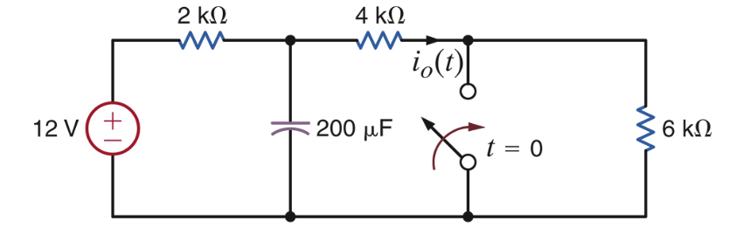

*Figure 1*

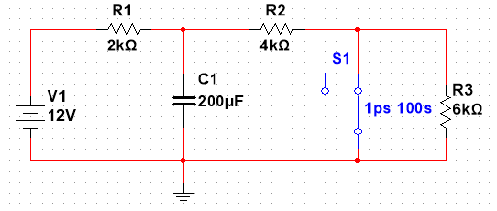

*Figure 2*

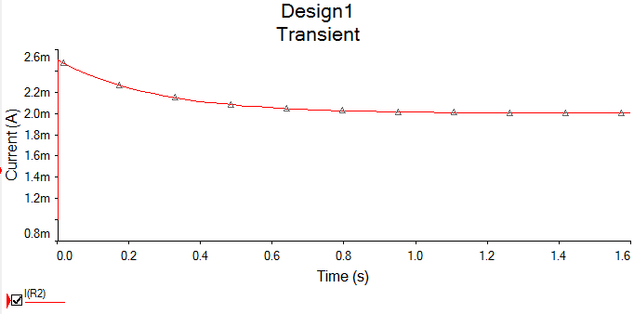

|  |  |
| --- | --- |
| **I0(t)** | 2t1/2e-15t/4 mA |

*Graph 1*

# Exercise 2

In exercise 2, we were asked to do the same thing as in exercise 1, but we must use the circuit in figure 3 shown below. Figure 4 shows the circuit constructed in multisim and graph 3 shows the graph.

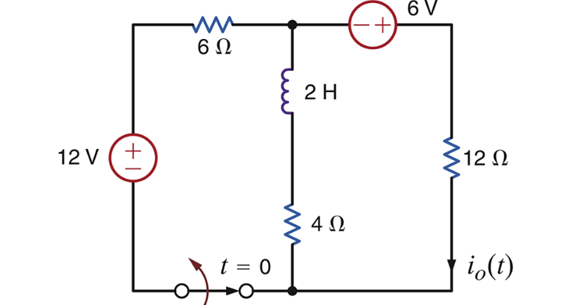

*Figure 3*

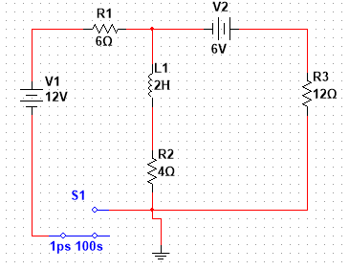

*Figure 4*

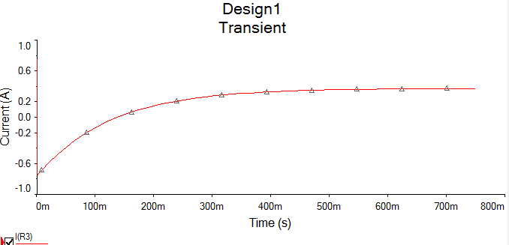

*Graph 3*

|  |  |
| --- | --- |
| **I0(t)** | 3/8 – (9/8)e-8t mA |

# Exercise 3

In exercise 3, it tells us that the switch in Figure 5 below has been closed for a long time and is opened at t = 0 [1]. Figure 6 shows the circuit constructed in multisim and graph 5 shows the graph.

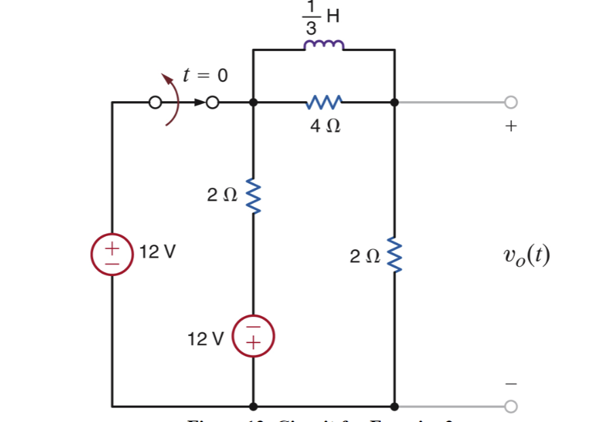

*Figure 5*

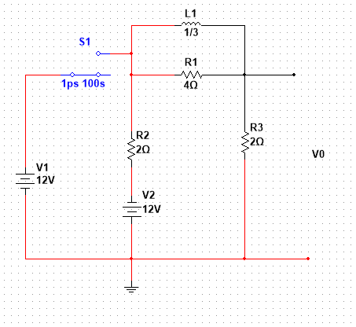

*Figure 6*

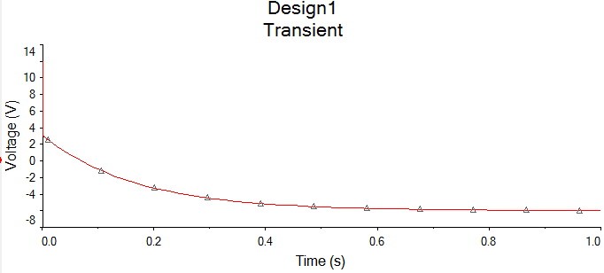

*Graph 5*

|  |  |
| --- | --- |
| **V0(T)** | 60e-6t – 48 V |

# Exercise 4

In exercise 4, it tells us that The switch in Figure 9 below has been open for a long time and is closed at t = 0 [1]. We must find V0(t) and plot the graphs in multisim and matlab. Figure 10 shows the circuit constructed in multisim and Graph 7 graph.

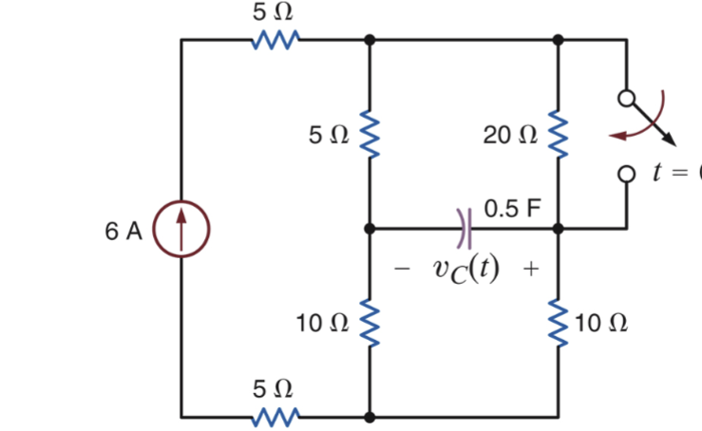

*Figure 9*

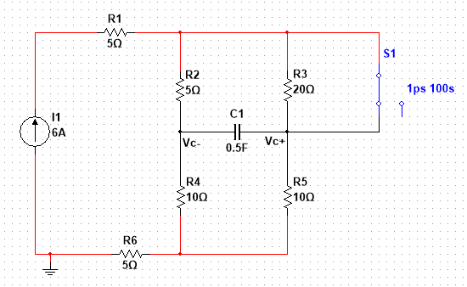

*Figure 10*

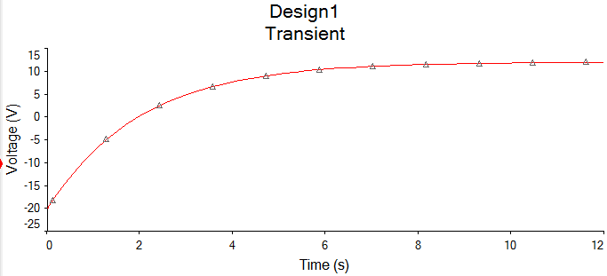

*Graph 7*

|  |  |
| --- | --- |
| **V0(T)** | -12 + 32e-t/2 V |

# Conclusion

This lab was used as an recitation for matlab and multisim, while introducing first-order transient circuits. I did run into some trouble with the graphs being incorrect, but the TA was very helpful on showing us how to get the correct graph.

# Bibliography

[1] Nelms, R. Mark, and Elizabeth Devore. *Recitation & MultiSim: Thevenin’s and Norton’s Theorems*. 2016, p. 5, Accessed 25 Sept 2019.